A Celebration of the Life
of

James Jeremy Stewardson

29th May 1993 – 12th November 1999

A little boy who was a leader of men, whose sweet innocence inspired an army of people into finding a cure for a very devastating illness. The fight goes on in James’s memory…………

James

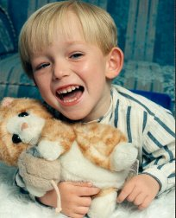
James was diagnosed with Triose Phosphate Isomerase (TPI) Deficiency, an enzyme deficiency, in April 1994 at the age of 11 months. We thought the end of our world had arrived, but James taught us otherwise.

James’s sheer determination and will to live pulled him through many emergencies during the next 5 ½ years and we thought we would have him for many more years to come.

James inspired and motivated people to stretch themselves to extraordinary heights ourselves included. He won the world with his beautiful smile and good looks and touched and gladdened the hearts of countless people. He enjoyed life and lived it to the full.

What a privilege it was to have you James as our son, our hearts are broken that you are no longer with us, but we hope the countless wonderful memories you have left us will eventually mend our broken hearts.

We will be forever your devoted Mum and Dad.

Order of Service

1. Entrance

Music - Titanic by Celine Dion

2. Welcome and Opening Prayers

3. Hymn - My Jesus, My Saviour

4. James’s stories and prayers read by Brother Christopher

5. Reading - Psalm 139

6. Tribute by Etchells School

7. James’s Song - I’ve got a home in Glory Land.

8. Tribute from “When You Wish Upon A Star”

9. Poem - Gods Lent Child

10. Hymn - Amazing Grace

11. Dad David’s Tribute

12. Music - Villa Lobos prelude No. 5 Played by Uncle Peter

13. Address By Rev. Billy Montgomery

14. Prayer

15. Hymn – Shine Jesus Shine

16. Benediction

17. Music from Walt Disney
Circle of Life

Brother Christopher’s Tribute

James loved to write his own stories, I’d just like to read a few short stories from his selection. The first one is called “Waver Woo.”

“They said waver woo, waver woo. They had a cup of tea and they got into a boat. They drank the cup of tea in the boat and they went over the Atlantic. Then they were at America in the morning. They went to a hotel. There was a hurricane a bomb and a twister all together. The End.

The next story has no name…

We were in a boat and we sailed off. We were caught up in a twister and we called for help before it sucked us up. It was too far round the corner and it was midnight and we ended up in a tree. The tree burst into flames and a flying ambulance had to come and the siren went off and it was too late. The boat fell out of the tree and crashed and we went to the airport and got a plane to England. The captain went into space by accident so we got the shuttle home. The End.

The next story is called “Imagine all your amazing imagination.”…

Once upon a time there was a little boy who found a monster in the park and the monster was called “Poppypoohead.” James asked Poppypoohead if the monster was going to eat him. The monster said yes but first I need more salt, James said I have no salt so you can’t eat me. The End.

In James’s last Sunday School he wrote a prayer with the teacher and the other children, I would just like to finish by reading this prayer to you….

James’s Prayer
(Composed and written by James at his last Sunday school)
James’s words were: Thank you god for the living, Thank you god for the bible, Thank you god for the stories of Jesus who died on the cross. Help us to take care of your world. Amen

James’ Favourite Song

“I’ve Got a Home In Gloryland”

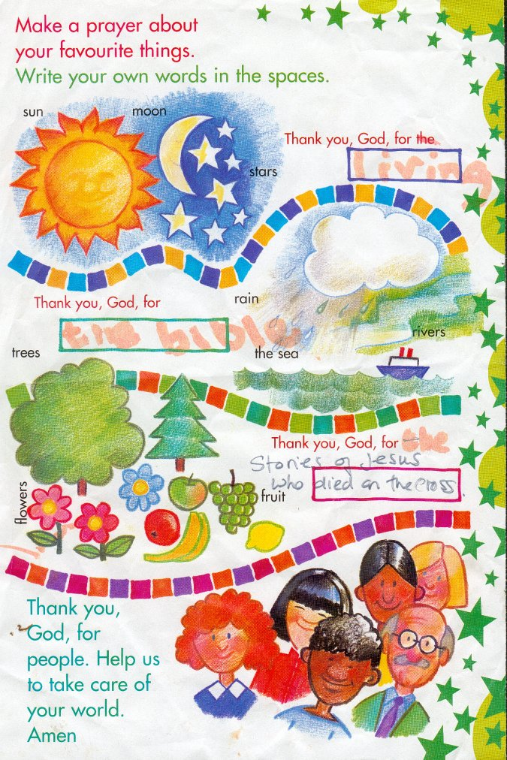

I’ve got a home in Gloryland that outshines the sun
I’ve got a home in Gloryland that outshines the sun
I’ve got a home in Gloryland that outshines the sun
Way beyond the blue

Do lord oh do lord oh Do remember me
Do lord oh do lord oh Do remember me
Do lord oh do lord oh Do remember me
Way beyond the blue

I took Jesus as my saviour you take him too
I took Jesus as my saviour you take him too
I took Jesus as my saviour you take him too
Way beyond the blue

Do lord oh do lord oh Do remember me
Do lord oh do lord oh Do remember me
Do lord oh do lord oh Do remember me
Way beyond the blue

Etchells School Tribute
(Read by Headmistress Mrs Holbrook and special needs teacher Mrs Edmunds)

James joined us in September 1997 to our delight. He was as nervous about big school as we were about providing the right education for him.

After a very short time, relationships and confidence grew and many happy times were ahead.

James, from the start, always showed his determination to be an active part in the class. His popularity, especially with the girls, was obvious from the beginning and children of every age liked to chat and joke with him.

We soon began to discover James had many hidden talents.

James the actor – whether he played the Troll or wolf, or Prince Charming on a cruise liner, the funny faces and frightening noises were all part of the act.

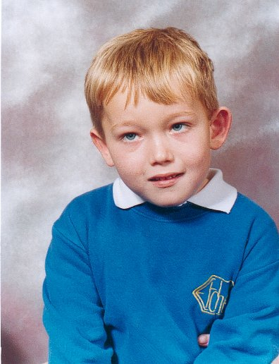
James the Doctor – Structured play sessions often turned into Peak Practice as James tried hard to take out Mrs Kemp’s major organs on the operating table.

James the writer – Weird and wonderful stories became his forte, with names such as ‘Poppy poohead’ being just one of the characters in his dictated horror stories and much giggling as the computer read them back.

James the Disco King – What a mover! Arms swinging, head swaying, favourite music playing and surrounded by girls. What more could he want.

James the Grand Prix Driver – Was the playground a dangerous place as he weaved around at top speed in his electric wheelchair?

Was James a chocoholic? We know so from the times he enjoyed being teased about sharing his chocolate snack and from his chocolatey grin!

Was James a snitch? Definitely! How he would gleefully tell tales to Mrs Edmonds and Mrs Holebrook about those he worked with.

Was James a Sciver? At times – one of the best – the times he spent in the toilet keeping us talking, reading or singing (especially with the out of tune Mrs Sambrook) rather than go back to the drawing board.

James and his qualities were loved by everyone. The spontaneous cheering at the 1999 Sports Day epitomised the childrens feelings for James who had his Mum in tow straight down the track.

We thank James’ family for allowing Etchells to share their wonderful little boy. He will always have a special place in our hearts.
James School photo
Titanic Song (Celline Dion)
(James’s favourite pop song)

Every night in my dreams, I see you, I feel you
That is how I know you go on.
Far across the distance and spaces between us,
You have come to show you go on.

Near, far, wherever you are
I believe that the heart does go on.
Once more you open the door
And you’re here in my heart
And my heart will go on and on.

Love can touch us one time, and last for a lifetime
And never let go till were gone
Life was when I loved you, one true time, I hold you
In my life will always go on.

Near, far, wherever you are
I believe that the heart does go on.
Once more you open the door
And you’re here in my heart
And my heart will go on and on.

You’re here there’s nothing I fear
And I know that my heart will go on.
We’ll stay, forever this way
You are safe in my heart
And my heart will go on and on.

Dad David’s Tribute

“James’s Journey of Life”

Yvonne and I have been dreading this time for 5 ½ years, but always knowing that one day we would have to release our wonderful son to heaven. We can see James smiling now as he runs around shouting his head off, free from the physical constraints he had here on earth.

James was born on a sunny Saturday afternoon on May 29th 1993. The delivery was traumatic and Yvonne had to have an emergency caesarean section. About 8 hours after James was born he needed a full exchange blood transfusion. James fully recovered very quickly and we soon had him home and all seemed normal. Then at 10 months of age James became very ill and our world fell apart. That day James began his many battles for life. It was 4 weeks before we were given the diagnosis but Yvonne and I had suspected James was seriously ill. When we were told James had a terminal illness and it was unlikely he would live beyond his 2nd birthday, we were devastated. For the next few months we were in and out of hospital and nearly lost James several times, but we very quickly realised James was a very special child and had been sent to us for a purpose. That purpose was to find a cure for this terrible disease.

The next 2 years were filled with wonderful memories as we came into contact with so many people who raised money for the TPI Trust, they all loved James on sight and we made so many new friends. We are so grateful to all of you as you gave us the inspiration to raise what eventually amounted to almost £340,000 for TPI research.

I have so many memories of James because he packed so much into his short life, everybody that knew James, knew he loved theme parks and the scarier the ride the better. He has been to Disneyworld Florida twice, Disneyland Paris twice and Alton Towers and Gulliver’s World too many times to count. To see his face light up when he would get wet on Splash Mountain or be knocked sideways on Thunder Mountain at the Magic Kingdom will live with me forever. On the Great Movie ride at Disney’s MGM Studio’s, James was frightened to death when the gangster came off the set and sat next to him, I had never seen him so frightened and excited before. We laughed many times about that afterwards and James would repeat what he said to the gangster at the time, UUGH! I don’t think the gangster was scared off!!

One particular memory, which showed the determination James had, was shortly after James became ill he was losing weight dramatically and it seemed the only way to feed James was via a feeding tube. Of course James had other ideas and hated the tube going through his nose into his tummy and he would repeatedly pull the tube out. On one occasion he got it slightly wrong and somehow pulled it out of his mouth instead of his nose leaving the tube hanging out of his nose and mouth. At the time Yvonne and I didn’t think it was very funny, but looking back that summed up James’s determination to do away with medical appliances. Needless to say he didn’t have the feeding tube again!

Another memory is of James’s love of chocolate, in fact it was probably chocolate that kept James alive when he wouldn’t eat during his early years. Chocolate cake for breakfast, lunch and dinner was normal for James. When eating chocolate he would use what became his most favourite word, “more.”

One of the best decisions we ever made for James was to send him to Etchells mainstream school at Heald Green. We were a bit wary at first about how a class full of able bodied kids would take to James, but because he was a highly intelligent and mature boy we were sure this was what he would want. Our fears were totally unnecessary as the children at Etchells were fantastic with James and he absolutely adored going to school. The teachers and carers at Etchells gave James so much love and attention that I am sure James considered school to be just an extension of his home life.

On the last afternoon of James’s life Mr’s Kemp, Mr’s Sambrook, Mr’s Edmunds and Anna Morgan from Etchells came to say goodbye to James. They sang him his favourite school song, “I’ve Got a Home in Gloryland” and although James couldn’t communicate at this stage, but we could tell he heard and enjoyed it so much. According to Mr’s Sambrook, James always insisted she sang “I’ve Got a Home in Gloryland” and many more songs to him when she took him to the toilet.

The last few minutes of James’s life were spent listening to Grandma read out all the hand-written get well cards from his classmates.

We are so grateful to all at Etchells School for how they made his school life so enjoyable and normal and we know there will always be a special place there for James. We know how much the staff and pupils at Etchells loved James and this helps us come to terms with his loss.

About 2 years ago we came into contact with Sue and Maria of Wish Upon a Star when they took us and James to Lapland to see Father Christmas. Further trips followed to Disneyland Paris, a Barney show at Wembley and a trip to Alton Towers. On these trips we got to know many other families whose children had terminal or life threatening diseases. On the Disneyland Paris trip one of the Dad’s was arrested by French police because he was looking through his recently acquired telescope at Paris airport. James almost laughed his head off when that happened. Wish Upon A Star certainly made dreams come true for James and made his life so much richer. Sue and Maria will be true friends of the family for life.

The research at Kings College Hospital in London involved Professor Bellingham, Dr. Mark Layton, Dr. Roopen Arya, Dr. Art Ationu and Anne Humphries, they are all wonderful people and did all they could to save James. We are sure the treatments they initiated for James during the last 4 years prolonged his life.

James was my best friend and I will miss him more than anything anybody could possibly imagine, there is a very big hole in my life now. I will forever remember the times we had bombing around the estate either on his motor bike, car, special needs tricycle, or walking. James would make me take him to some far off places, nearly always culminating at the local shop for chocolate, lottery tickets and then into the Shady Oak pub for his glass of coke. I will remember his toileting habits, I think we must have been to every public toilet in Manchester during the last few years. He always picked the wrong place and time, on one occasion we were at the top of the big wheel in Manchester Piccadilly and I don’t’ think the people directly below were too pleased. He left his mark all over the Disney rides also!

Each Saturday morning James would tell me where to take him, it could be Stockport to buy him something, the swimming baths, train ride to Manchester, Bramhall Park, Bruntwood Park, long bike ride and many more. Most outings would end up with a Macdonald’s.

To have James until he was 6 ½ years old was a wonderful bonus to us and we are sure he packed enough into those years that no other child could do in a lifetime.

James, you will forever be in our thoughts.

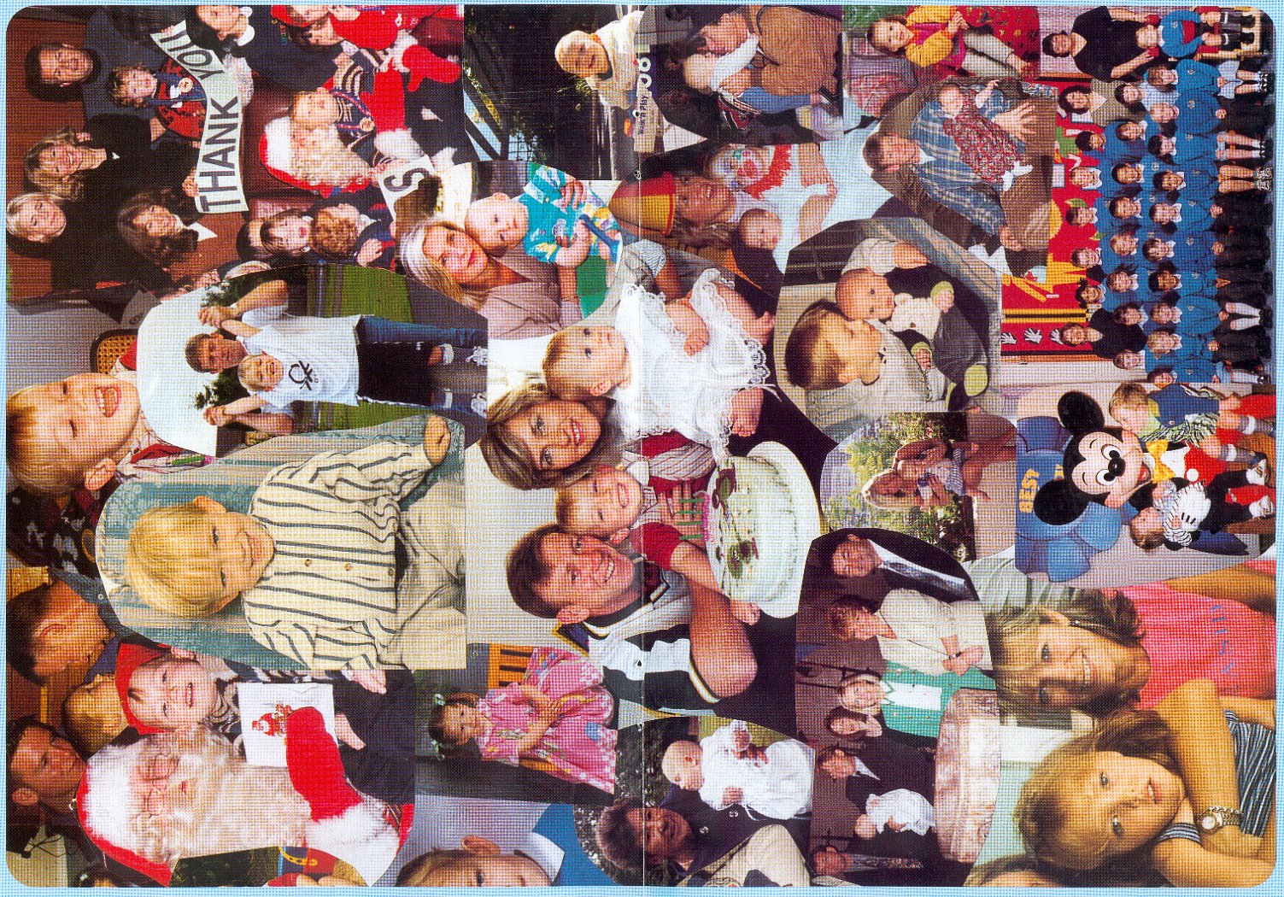

When You Wish Upon A Star Tribute

“Dream Making for Sick Children” Charity No: 1060963

Maria and I at “When You Wish Upon A Star” are proud to have been adopted by James and his family. It is of course for us to do the adopting, but as we all know, James Stewardson was a very special little boy, who came from a special family and I think it is more accurate to say he adopted us!

James had a voracious appetite for life, surpassed only by his voracious appetite for chocolate!

He managed to pack a huge amount of living into every single day, leaving the rest of us mere mortals breathless and trailing in his wake.

His razor sharp brain and a wicked sense of humour enabled him to lead the fundraising for his trust with the aplomb of a seasoned professional. The fact that he still found time to front many of our campaigns speaks volumes for his energy and determination to live life to the full.

James is probably the one person responsible for putting “When You Wish Upon A Star” on the map and played a leading role in our success story, sustained by chocolate sandwiches, of course.

His “circle of life” may seem short to us, but the many magical memories and shared experiences James leaves behind, will enrich and inspire us all for many years to come.

We are grateful that God chose to lend James to us and I would like to share words written by Edgar Guest with you…

God’s Lent Child
I’ll lend you for a little while
A child of mine, god said
For you to love the while he lives,
And mourn for when he’s dead.
It may be six or seven years
Or twenty two or three,
But will you, till I call him back
Take care of him for me.
He’ll bring his charms to gladden you.
And should his stay be brief,
You’ll have lovely memories
As a solace for your grief.

I cannot promise that he’ll stay
Since all from Earth return.
But there are lessons taught down there
I want this child to learn.
I’ve looked the whole world over
In my search for teachers true
And from the throngs that crowd life’s lanes,
I have selected you.

Now, will you give him all your love?
Nor think the labour vain,
Nor hate me, when I come to call
And take him back again.

I fancied that I heard them say
Dear lord, thy will be done,
For all the joy your child shall bring,
The risk of grief we’ll run.
We’ll shelter him with tenderness,
We’ll love him while we may,
And for happiness we’ve known,
Forever grateful stay.

But should the Angels call for him
Much sooner then we’d planned
We’ll brave the bitter grief that comes,
And try to understand.

James Stewardson TPI Trust

In July 1994 we formed the TPI Trust charity named, “The James Stewardson Research and Welfare Trust for Children with TPI.” The aim of the Trust is to fund research into finding a treatment or cure for James’s illness, Triose Phosphate Isomerase (TPI) deficiency. The Trust has raised almost £340,000 in just over 5 years for TPI research.

The research has been taking place at Kings College Hospital in London and National Institute of Haematology, Blood Transfusion and Immunology in Budapest. We have no doubt the treatments James has received as a result of the TPI research has lengthened his life.

The research into finding a treatment or cure for TPI deficiency was too late for our son James, but it will continue and hopefully save the lives of the remaining six TPI children world-wide. We will continue in James’s memory to front the research and TPI Web Site http://www.gconnect.com/users/tpi/ on behalf of the other families.

The TPI Trust is currently committed to finance the research until the end of 1999, as this is when the funds will run out. Kings College are waiting on our go ahead to fund the research beyond this date.

Donations to the TPI Trust should be made payable to “The James Stewardson TPI Trust” and sent to:

Dave and Yvonne Stewardson
19 Duncombe Close
Bramhall
Cheshire
SK7 3DD
Tel: 0161-439-3146

Special Thanks

James was the centre of our World and it took an army of devoted people to support him. Special thanks to Grandma, Granddad and Uncle Peter who were there every day for James, devoted and dedicated. He loved you all so dearly. Thanks to our French Maid Rachel, who scrubbed floors, hoovered, washed and cooked, who brought humour and fun and made all our lives much brighter. To Auntie Debbie James’s Godmother who waved her magic wand and always had magical surprises for James.

We Wished Upon a Star and Maria and Sue took James and family on many adventures, to Lapland, Disney Paris, Barney and Alton Towers, but more that that they gave us tons of love, heaps of support and wise advice. To Auntie Chris who stroked James’s arms like no one else could. Then God gave Matthew Maccallum a special gift, to play with James like no one else could.

Our sincere thanks to Valley School who gently prized James off Mum’s knee and helped him grow. Blessings from above where poured onto us when James started Etchells School. There he experienced a normal happy school life, he was able to achieve his full potential and we are forever grateful. Special thanks to Mrs Kemp, Mrs Sambrook, and Mrs Frost who cared for James in a very loving way. To Mrs Holebrook and her exceptional staff who made James’s integration possible. Finally school life was made complete by the children, especially Rachel, Abby and Gabi, who kept us amused with their love notes to James.

To Auntie Sheila, Auntie Sue and Janis from Crossroads who loved and cared for James for many years and gave us welcome breaks to catch our breath.

Our thanks also to Professor Bellingham who opened the door of opportunity. To Mark Layton for his tremendous support over many years. To Art, Ann and Roopen our researchers, we know how hard you have worked, you have achieved so much, our sincere thanks.
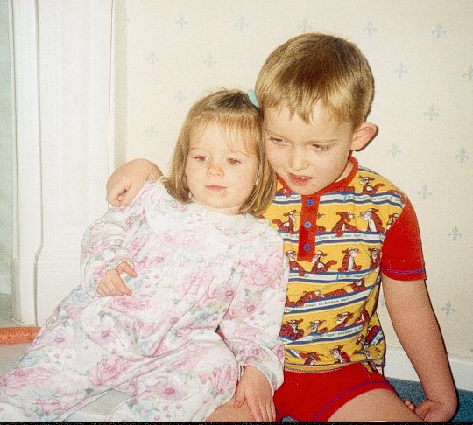
To Professor Hollon and her team in Hungary, for their dedication and commitment.

Our thanks and gratitude to Dr Lacey, Dr Will and Dr Yates who gave their best at all times. So many nurses, so many therapists helped us along the way. We are grateful to you all.

How can we thank the thousands of you who dug so deeply into your pockets and worked with so much dedication to raise a staggering £340,000? We haven’t a clue. We feel thank you is inadequate, but we know what you did for James. May God bless you all.

Dave and Yvonne.

James message to sister Georgia

My Georgia,

I have died and gone to Heaven to live with Jesus. It’s wonderful here. I have a new heavenly body, I can walk, sit, jump and run, just like you now. I have met up with my friends Michael Jagger and Miles Hull, and guess what Georgia I can play football!

I know you will be sad that I have gone, but be happy that I am with Jesus, and one day when you are a very old lady we’ll meet up in Heaven. I’ll be waiting for you with a bar of chocolate at Heavens Gate, or would you prefer crisps?

I love and adore you - James

